Steps to write shell program

- Using gedit write your code in a file and save it with extension .sh e.g.
#gedit hello.sh

- Always write the first line in your shell script as
#!/bin/bash

e.g. a shell script file is

#!/bin/bash
echo "Hello world"
echo "I have arrived"
echo "home"
echo "$home"
total =20
echo "$total"
save it as hello.sh and execute.

- Execute the above shell script by
#./hello.sh

- To save the output in another text file
#./hello.sh > out.txt

Steps to create shell program in C language and execute them:
- Mount CD2.

- Open terminal and install gcc package which is in cd2. Type as per the following command to install gcc package.

Rpm –ivh /mnt/cdrom/RedHat/RPMS/gcc-3.2.2-5.i386.rpm

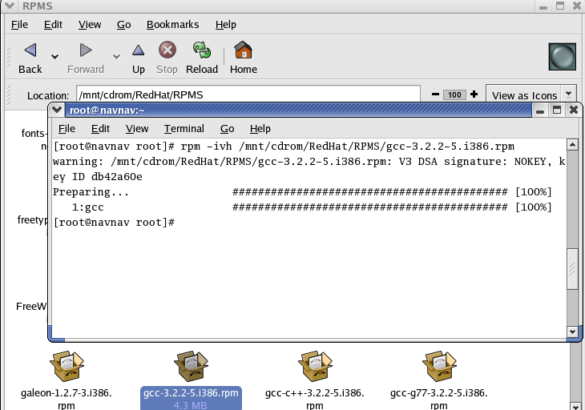

- Now go to terminal and create a file with extension c. For example : I have created a file hello.c
When you will press enter after typing the command , it will ask you “Would you like to create it?” Click on Yes
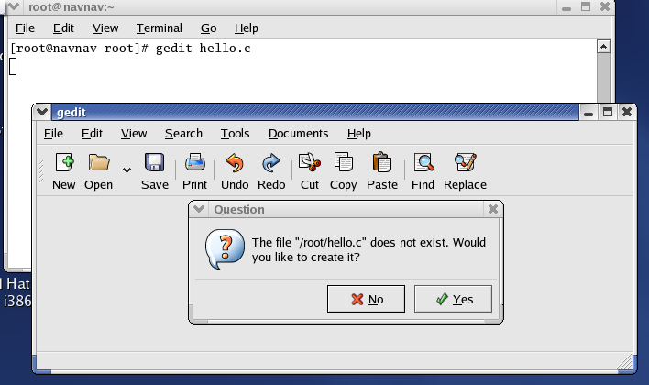

- Now type the program in hello.c file as follows and save it
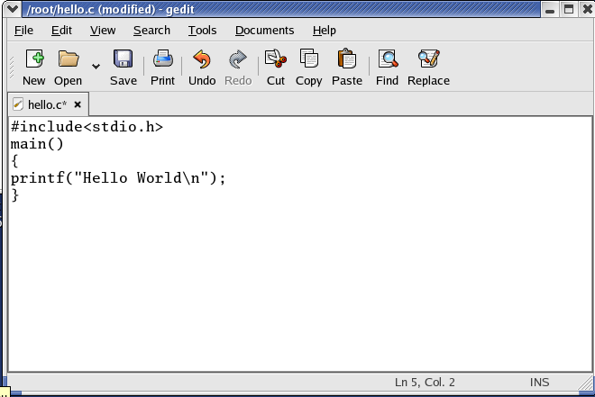
Save it and close it.
- Now compile this C program using the following command. Gcc compiler is used to compile the program.

# gcc –o hello hello.c

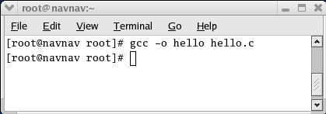

- To get the output of the program type the following command on terminal
# ./hello

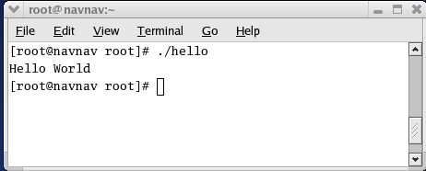
It will show the output.

Now you can create C program to find even number, odd number, prime number, Factorial, Fibonacci series etc and execute the C programs in RedHat linux as per the above mentioned steps.

